Assignment 1

# A Simple Feedback and Control Loop

Course: Tech1102

Instructor: Dima Marachi

Student: Sasha Greene

Institution: Bow Valley College

## Q1. Please paste in the Arduino code for your very smart water level sensor.

int sensorPowerPin = 1;

int fanPin = 4;

int pumpPin=6;

int currentDesiredLevel=0;

int desiredLevel=10; //base desired level value in mm

int potentioValue=0;

int sensorValue = 0;

void setup() {

Serial.begin(9600);

pinMode(fanPin,OUTPUT);

pinMode(pumpPin,OUTPUT);

digitalWrite(sensorPowerPin, HIGH); // turn the sensor ON

currentDesiredLevel=desiredLevel; //set current desired level (the user variable ) to be the desired level(initial value set).

}

void loop() {

potentioValue = analogRead(A8) + 1 - 512;

//The logic behind this is that the potentiometer goes from 0-1023 and i want an even number to divide by,

//so i add 1 making it 1-1024. We will be using the middle of this as our "0" point so anything above

//(1024/2) or 512 is positive while below that will be negative

sensorValue = analogRead(A1); // read the analog value from sensor

sensorValue = sensorValue*30/1023; //approximate conversion to mm (sets range to 0-30)

currentDesiredLevel = desiredLevel+(desiredLevel*potentioValue/512); //set the current desired level as a % of the potentiometer (based on original level) if max potentiometer, should be approx 20 mm, double the original.

//It should be noted that this value is always rounded down.

//Logs all relevant values so we can make sure it is working correctly.

Serial.println("-------Log Start-------");

Serial.print("Sensor reading(mm): "); //This shows what our water sensor is picking up as the water level.

Serial.println(sensorValue);

Serial.print("Desired level(mm): "); //this is what we have set the current desired water level to be.

Serial.println(currentDesiredLevel);

Serial.println("-------Log End-------");

if(sensorValue>currentDesiredLevel+5){ //if when sensor goes 5 mm over desired level

digitalWrite(fanPin, HIGH);//turn fan on

}else{

digitalWrite(fanPin, LOW);//turn fan off

}

if(sensorValue<currentDesiredLevel-5){ //if sensor goes 5 mm under desired level

digitalWrite(pumpPin, HIGH);//turn pump on

}else{

digitalWrite(pumpPin, LOW);//turn pump off

}

delay(5000);

}

## Q2. If the water level sensor was installed in your fish tank, but unfortunately was installed very close to a source of water turbulence (bubbles or a tank filter), what problem would you encounter and how could you mitigate this problem using software?

You would encounter fluctuating water level readings from the water sensor since the water would not be still where you are taking the reading. The best solution I think would be to take multiple readings over a set period of time and take the average of all of those readings.

## Q3. Take a picture of your circuit and paste it here.

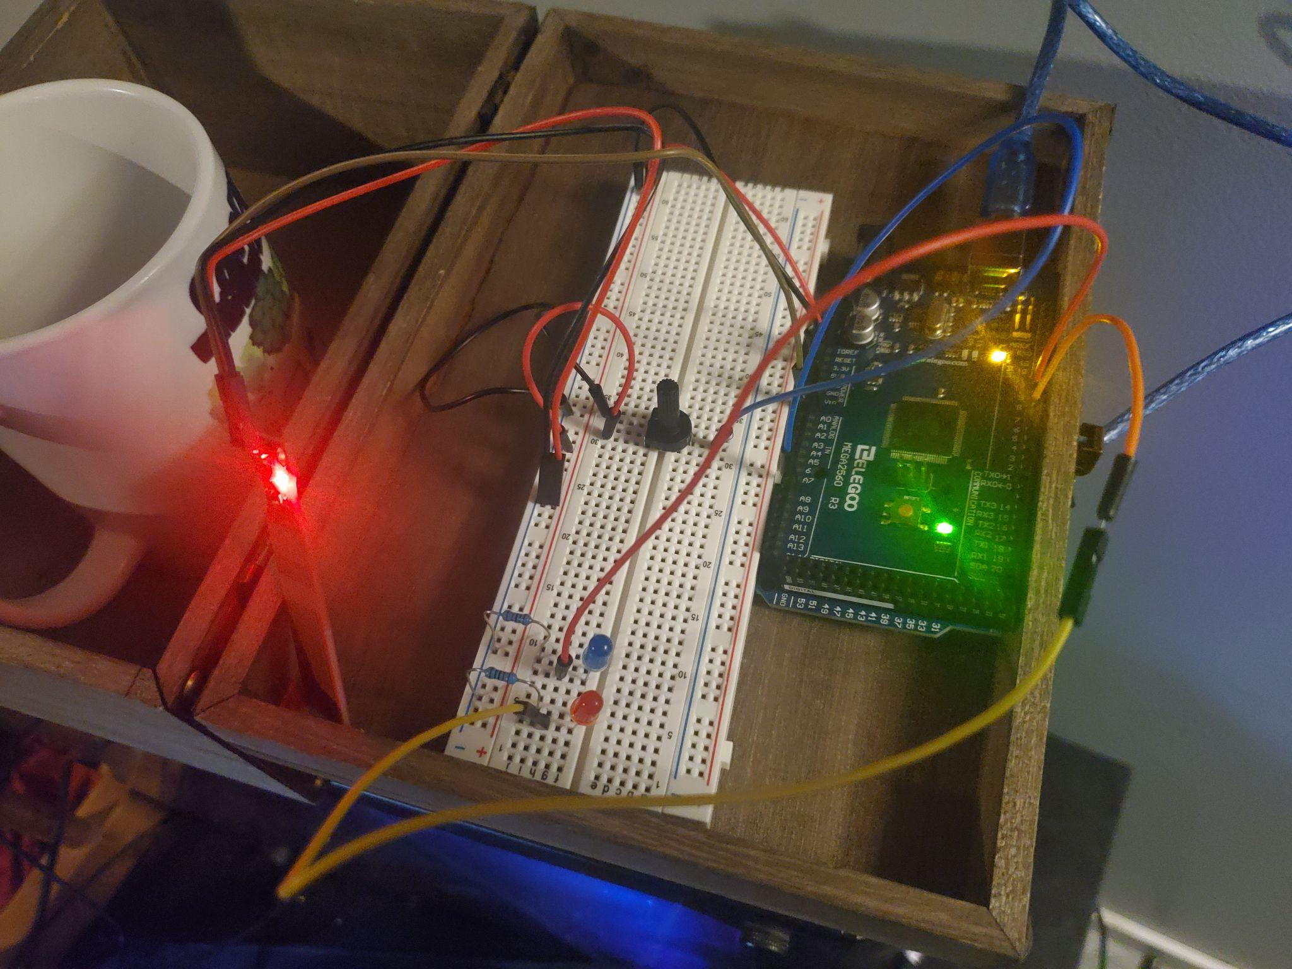

The way I had to set this up to connect to my computer is a little awkward( i put it in a box in case I spilled) but the video I think shows off my circuit better.

## Q4. Take a short video of your working circuit while showing all the results and upload it on D2L when you are submitting your work.

Link: <https://www.youtube.com/watch?v=F9zM4ShLdGY&ab_channel=SashaGreene>